WP1 : Gestion de projet et management administratif

WP1: Gestion de projet et management administratif
Duration |  | Mx - Mx |  | Lead beneficiary
Objectives (expected outcome)
Description of the activities (what, how, where) and division of work
No | Task Name | Description |  |  | Participant |  | In-kind contributions and subcontracting  (yes/no and which)
 |  |  |  |  | Name | Role
x.0
x.1
x.2
x.3
x.4
x.5
No | Milestones Name | WP | Lead beneficiary | Means of verification |  | Due date | Description
MS1
MS2
MS3
MS4
No | Deliverable Name | WP | Lead beneficiary | Type | Dissemination | Due date | Description
Dx.1
Dx.2
Dx.3
Dx.4
Dx.5

WP2 : COMMUNICATION & PROMOTION
WP2: COMMUNICATION & PROMOTION (Solutions&co)
Duration |  | Mx - Mx |  | Lead beneficiary
Objectives (expected outcome)
The aim of the communication and promotion work package is to define a strategy and a relevant action plan to address the messages to all of DIVA's targets and to support its deployment. Communication actions must therefore reflect and evolve with the strategy and objectives of DIVA during the 3 years :
YEAR 1 : AWARENESS
YEAR 2 : VISIBILITY and COMMITMENT
YEAR 3 : SPREAD
This work package will also aim at shaping, commit and spread the future of IA (What IA do we want ?) wanted by the regional actors through the designing and communication of a code of conduct, at regional and national / European levels
Description of the activities (what, how, where) and division of work
No | Task Name | Description |  |  | Participant |  | In-kind contributions and subcontracting  (yes/no and which)
 |  |  |  |  | Name | Role
x.1 | Communication strategy | Based on the vision of the eDIH, its strategy, its services and its positioning, define a communication strategy at regional, national and European levels :  - Define a communication positioning in line with the orientations and vision of DIVA  - In line with other DIVA WP leaders and DIVA strategy, define the eDIH communication targets (users and prescribers of DIVA offer, others eDIH and European Regions in line with economic sectors targeted for networking) and related communication objectives  - Define communication objectives at 3 years in response to the development and deployment challenges of eDIH :  - Y1 : AWARENESS  To know DIVA offer. Build a DIVA community to share and work on visibility and clarity of DIVA and its services offer → Targets: Regional companies / digital and other economic networks / associations of citizens specialized on IA / digital  - Y2 : VISIBILITY and COMMITMENT  To join DIVA offer and act. Enter more projects thanks to commercial communication approach.  → Targets : Regional companies / digital and other economic networks / associations of citizens specialized on IA / digital + national / European levels (eDIH, networks, hubs, etc)  - Y3: SPREAD  To accelerate and guide AI growth with DIVA. Promote AI projects supported by DIVA and its code of conduct (see below). Leverage on attractiveness of the territories and its companies at regional and European level.  → Targets : Regional companies / networks / associations of citizens specialized on IA / digital + national / European levels (eDIH, networks, hubs, etc) |  |  | S&co  Atlanpole & EMC2 | Leader  Participants (Link with DIVA strategy)
x.2 | Communication plan | Define a communication action plan at 3 years :  - Y1 : Initiate communication actions with the creation of a website built on a user-centered approach to publicize and make accessible the range of services to regional users.  - Give visibility to the website via webmarketing actions for DIVA targets (geography, size and sector of activity of regional companies)  - Enhance visibility with social networks via the creation of a DIVA linkedin page  - Press relations : Press releases about DIVA  - Communication toolkit to support des prospection actions  - Coordinate (link with prospection WP) events presence on regional main digital and innovation events (Connect, Digital Change, Inovdia, Web2day), outside the Region (main digital events, learning expeditions) but also on sectoral events targeted by DIVA (Industry, Health…)  - Y2 : continue the actions initiated at the regional level and initiate communication at the national / European level, with the aim of sourcing projects by promoting projects already carried out thanks to DIVA, the benefits and the value brought by AI for the territory at economic, social level, etc. via actions of:  - Orient webmarketing actions, social networks and website animation on content creation and message dissemination to be identified and recognized as a reference territory for AI  - Coordinate events presence (link with prospection WP) to give visibility to IA projects supported by DIVA and DIVA value added  - 2-year review of DIVA actions and results of DIVA (Marketing document and annual event “Les assises de IA”)  - Press relations : press trips to discover AI projects and the specificities of the Pays de la Loire region  - Y3 : Accelerate the promotion of DIVA by emphasizing the territorial dynamics on AI and the DIVA footprint (code of conduct). DIVA becomes an attractive tool for the territory and its companies. Share the regional vision on the development of AI to contribute to the emergence of a European vision and counterbalance the uses of AI by powers like the EU and China.  - Continue the communication actions initiated in previous years (website, social networks, webmarketing, press relations, event presence) with a focus on external targets and future of IA (i.e.. Code of conduct)  - 3-year event review of the actions and results of DIVA (Marketing document and annual event “Les assises de IA”), including other eDIH, to promote collaborations and AI partnership projects at national and European level |  |  | S&co  ADN Ouest ?  I&R ?  CCIR ? | Leader  Link with Event presence and prospection actions
x.3 | Future of IA and lobbying | Create a regional working group composed of regional companies, DIVA core team leaders, local politicians and local associations of citizens specialized on IA / digital, to share a vision and to build a DIVA code of conduct about which AI do we want for our territory and Europe in the future. This code of conduct and vision shall include uses of IA (applications, etc), Ethic frame (human centric, human rights, etc) and sustainable development of IA (environmental impacts, energy consumption, etc)  - Y1 : FRAME. Create the working group that will include a balanced and relevant members, engage discussions and write a draft of the DIVA code of conduct. Embark and liaise with other DIVA core team members :  - Create and lead the working group  - Organise internal meetings with other Core Team DIVA members in order to share ideas and decide how the code of conduct shall apply to companies using DIVA services  - Draft and create a “marketable” version of the code of conduct  - Y2 : COMMITMENT. Share the vision to commit other DIVA community members and other regional economic actors  - Internal communication (Newsletter, etc) to other DIVA members  - External communication to regional digital networks and to economic regional networks (Press relations, local public events/ meetings, social networks, DIVA website, etc)  - Y3 : BUILD UP. Spread the vision to build up with national and European networks (eDIH)  - Communicate DIVA vision of IA to other regions at national and European levels with the objectives to build up and have more impact on digital and economic ecosystems. This would imply press releases, presence on national and European IA or digital events, meetings and networking strategy with other relevant eDIH. |  |  | S&co  Atlanpole & EMC2  Others | Leader
No | Milestones Name | WP | Lead beneficiary | Means of verification |  | Due date | Description
MS1
MS2
MS3
MS4
No | Deliverable Name | WP | Lead beneficiary | Type | Dissemination | Due date | Description
Dx.1
Dx.2
Dx.3
Dx.4
Dx.5

Services
Description of the service | Market price (€) | Unit of measure | Reduced price offered to SMEs (€)
Plateforme d’accès et d’information à l’offre de services DIVA
Visibilité aux entreprises et aux projets soutenus par DIVA
Offre d’accès aux évènements numériques nationaux et européens (délégation d’entreprises, learning expéditions, etc)
Contribuer à l’écriture d’une charte des usages souhaités de l’IA par l’écosystème régional à travers un groupe de réflexion ouvert et a minima constitué de différentes parties prenantes (Core Team, entreprises, associations / citoyens)

WP3 : PROSPECTION ET DIAGNOSTIC
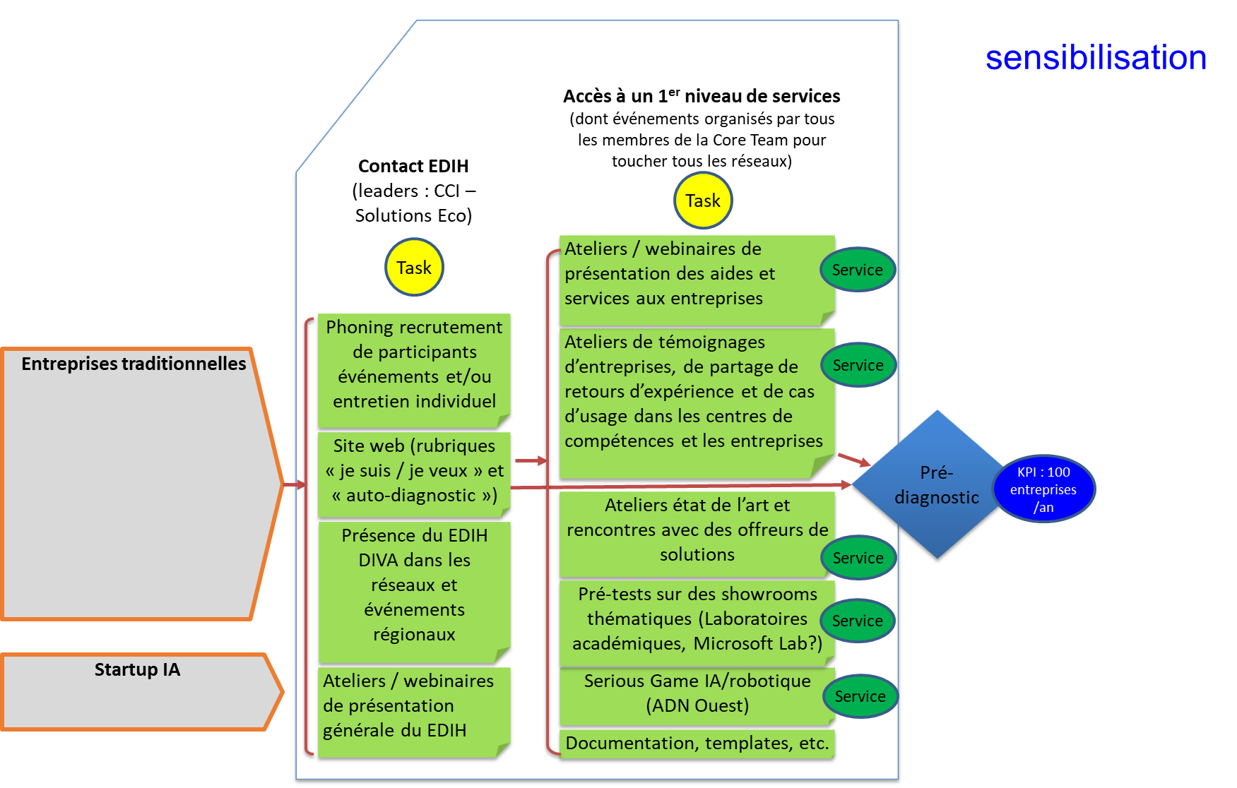
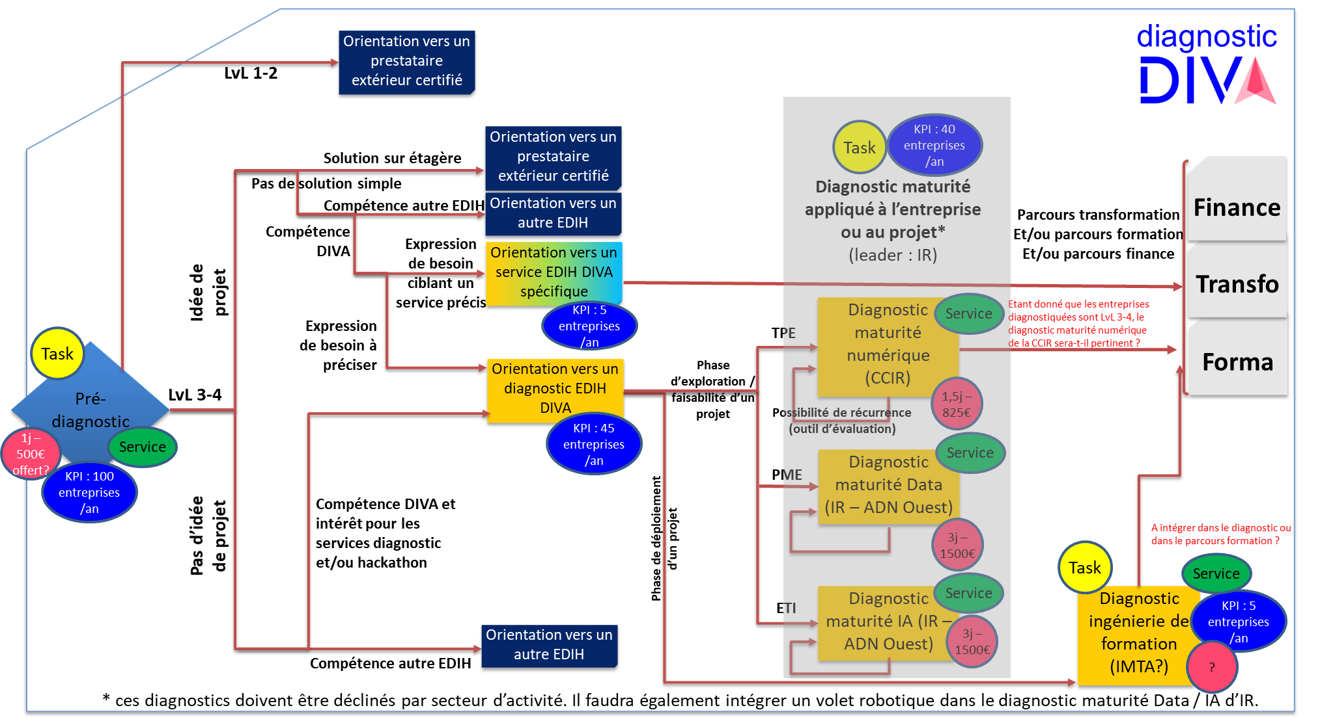
WP3: PROSPECTION ET DIAGNOSTIC (CCIR – ADN Ouest – Solutions&co – I&R)
Duration |  | Mx - Mx |  | Lead beneficiary
Objectives (expected outcome)
Description of the activities (what, how, where) and division of work
No | Task Name | Description |  |  | Participant |  | In-kind contributions and subcontracting  (yes/no and which)
 |  |  |  |  | Name | Role
x.0 | Initialisation & setup of the activities | 1. Définition des critères des cibles de DIVA  2. Identifier un prestataire pour la prospection des entreprises cibles de DIVA  3. Identifier les événements organisés par les partenaires pour s’insérer dans ces évènements afin de promouvoir DIVA, au niveau régional et européen  4. Identifier une base de données d’entreprises témoins  5. Identifier une liste d’offreurs de service  6. Construire une liste de questions type pour le « prédiagnostic »  7. Construire les diagnostics de maturité numérique, data et IA
x.1 | Sourcing and first contact | Dans l’optique de générer des contacts :  1- Phoning pour présentation des services DIVA  2- Présentation de DIVA dans les réseaux et événements des partenaires DIVA
x.2 | Open-access awareness rising services | 1- Ateliers / webinaires trimestriels de présentation des aides et services aux entreprises DIVA  2- Ateliers de témoignages d’entreprises, de partage de retours d’expérience et de cas d’usage data/IA dans les centres de compétences et les entreprises  3- Speed business meeting entre des offreurs de solutions et des entreprises ayant des besoins data / IA, identifié lors des diagnostics  4- Serious Game IA/robotique
x.3 | Pre-diagnosis | L’objectif du prédiagnostic, sous forme d’entretien structuré à partir d’un questionnement adapté, est de :  - préciser le besoin de l’entreprise,  - l’aiguiller vers le partenaire/service adapté au sein de DIVA, ou vers un autre prestataire.
x.4 | Maturity assessment | En fonction des projets des entreprises, de leur secteur d’activité et taille, des diagnostics de maturité seront proposés :  - Maturité numérique (cible TPE / PME n’ayant pas encore de projet data/IA mais l’envisageant) : évaluer la maturité numériques selon 5 axes (transformation des offres, processus interne, pilotage, RH, data,…)  - Maturité data : ?  - Maturité IA  - Le statu quo fournit une indication précise du niveau actuel d'IA au sein de l'organisation  Aperçu des points de vue divergents au sein de l'organisation  Comparaison avec les pairs du secteur sur la base du pool d'analyse comparative de la maturité de l'IA  Tirer le potentiel de développement:  Identifier les principaux domaines d'action et d'amélioration avec un objectif clair  Trouvez une approche structurée des activités qui intègrent davantage l'IA dans l'organisation  Suivre le progrès:  L'évaluation répétée de la maturité permet de mesurer les progrès vers la maturité de l'IA
x.5 | Skills & training assessment | A conserver ? A positionner dans le bloc formation
No | Milestones Name | WP | Lead beneficiary | Means of verification |  | Due date | Description
MS1
MS2
MS3
MS4
No | Deliverable Name | WP | Lead beneficiary | Type | Dissemination | Due date | Description
Dx.1
Dx.2
Dx.3
Dx.4
Dx.5

Services
Description of the service | Market price (€) | Unit of measure | Reduced price offered to SMEs (€)
Ateliers de témoignages d’entreprises, de partage de retours d’expérience et de cas d’usage dans les centres de compétences et les entreprises
Ateliers état de l’art et rencontres avec des offreurs de solutions
Pré-tests sur des showrooms thématiques (Laboratoires académiques, Microsoft Lab?)
Serious Game IA/robotique (ADN Ouest)
Pré-diagnostic
Diagnostic maturité (numérique / Data / IA)
Diagnostic ingénierie de formation

WP4 : Ecosystem and networking
WP4: Ecosystem & Networking
Duration |  | M1 – M36 |  | Lead beneficiary |  |  | EMC2
Objectives (expected outcome)
- Develop the European network to enhance the offer of services and technological solutions to users of E-DIH DIVA
- Organize joint-events with other E-DIH across Europe to liven DIVA up in the region and beyond thus ensuring the outreach of IA within Digital Europe
- Mobilise the regional community of practice to maximise the outcomes and impact
Description of the activities (what, how, where) and division of work
No | Task Name | Description |  |  | Participant |  | In-kind contributions and subcontracting  (yes/no and which)
 |  |  |  |  | Name | Role
x.0 | Finalizing the mapping of complementary IA technologies available in partnered E-DIH | M1-M3 Participants: EMC2, I&R, Solution&Co  Finalize an exhaustive mapping or listing of the already existing technological offers of IA in partner E-DIH complementary to DIVA available-ones. + Update during DIVA lifespan (M4-M36) ?
x.1 | Involvement in E-DIH Network | M1-M36 Participants: EMC2  This task consists on participating to the new DIHNET precursor network to continuously updating the map of HPC & Cybersecurity technologies available in other E-DIH and provide inputs about DIVA IA technologies and testing platforms. In addition, events funded through H2020 projects (such as I4MS) will be widely additionally advertised. This task also carries out seminars with similar E-DIH (focusing on IA for industrial SME) to brainstorm about the evolving needs of E-DIH users and adapt the offer of services accordingly.
x.2 | EEN | M1-M36 Participants: Solution&Co, EMC2
x.3 | Services to users based on networking actions | M1-M36 Participants: EMC2, …  This task consists on updating the offer of services to DIVA users linked with networking actions at European level.
x.4 | Raise the awareness of the regional community of practice through online events | M3-M36 Participants: EMC2, I&R, Atlanpole, CCIR  This task consists on organizing digital challenges (e.g. hackathons), B2B meetings between potential end-users (SME) and techno providers, organizing Learning Expedition (LEX) to meet SME across Europe with similar digital need, organizing Experience Days (including technical and business coaching) on particular technologies featuring IA.
x.5
No | Milestones Name | WP | Lead beneficiary | Means of verification |  | Due date | Description
MS1 |  |  |  | introduction to actions carried out within WP4 during DIVA lifespan, assessment of successes, lessons learnt and ways of improving (events & services). |  | M18
MS2
MS3
MS4
No | Deliverable Name | WP | Lead beneficiary | Type | Dissemination | Due date | Description
Dx.1 | List of already existing IA offers |  | EMC2 | R | PU | M3
Dx.2 | EEN action plan |  | Solutions&Co | R | PU | M3
Dx.3 | Communication plan featuring online and real-life events Update at M18 (as a mean of verification of MS4.1) |  | EMC2 | DEC | PU | M6  M18
Dx.4 | Services linked with networking accessible via DIVA website  Update at M18 |  | EMC2 | DEC | PU | M3  M18
Dx.5 | WP4 Final Report: introduction to actions carried out within WP4 during DIVA lifespan, assessment of successes, lessons learnt and ways of improving to match with a forever changing world |  | EMC2 | R | PU | M36

WP5 : Test before invest
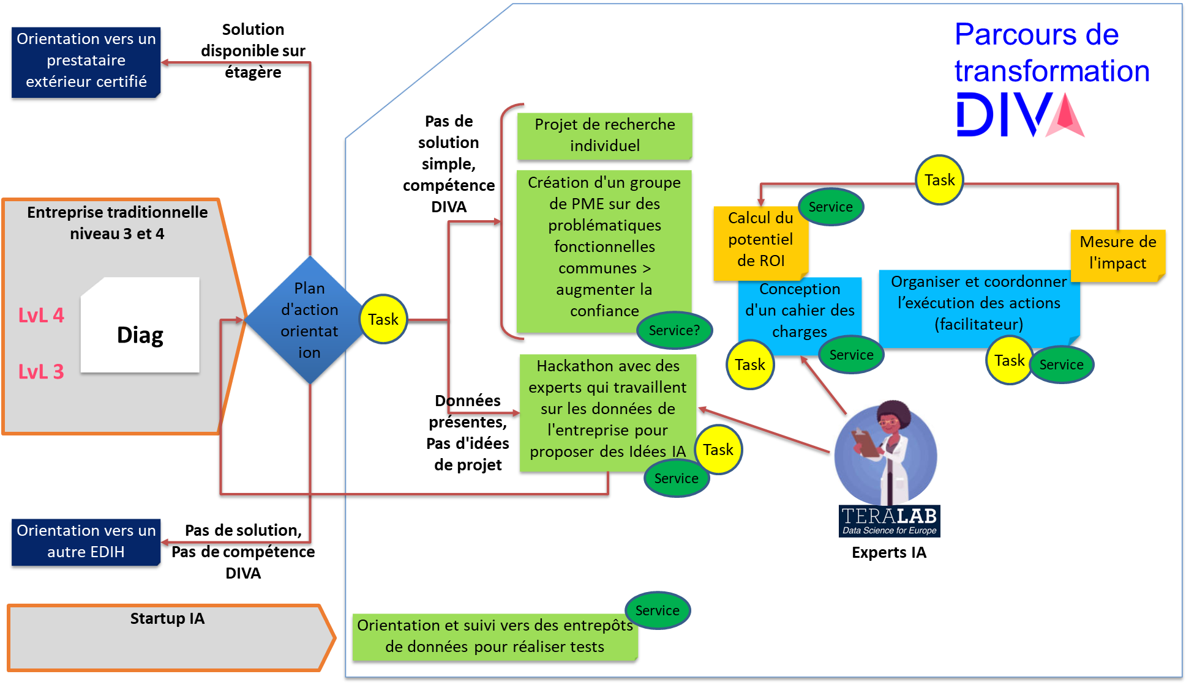
WP5: TEST BEFORE INVEST (EMC2 – IMTA – Atlanpole – Laval Mayenne Technopole)
Duration |  | Mx - Mx |  | Lead beneficiary
Objectives (expected outcome)
Description of the activities (what, how, where) and division of work
No | Task Name | Description |  |  | Participant |  | In-kind contributions and subcontracting  (yes/no and which)
 |  |  |  |  | Name | Role
x.0 | Initialisation & setup of the activities
x.1 | Action plan
x.2 | Transformation plan management & follow-up
x.3 | Specifications of needs and projects
x.4 | Return on Investment calculation
x.5 | Hackathon
 | Acces aux plate-formes de test
No | Milestones Name | WP | Lead beneficiary | Means of verification |  | Due date | Description
MS1
MS2
MS3
MS4
No | Deliverable Name | WP | Lead beneficiary | Type | Dissemination | Due date | Description
Dx.1
Dx.2
Dx.3
Dx.4
Dx.5

Services
Description of the service | Market price (€) | Unit of measure | Reduced price offered to SMEs (€)
Transformation plan management & follow-up
Specifications of needs and projects
Return on Investment calculation
Hackathon
Integration into groups of SMEs with common needs and challenges?
Networking with data hubs for testing and validating technologies
Plate-forme Teralab | En cours de définition par Frédéric Pallu (données pour début Mars)
Hall 6 Ouest eXpérience Lab | En cours de définition avec Julien Laflaquière / Murielle Manin / Patrick Le Callet
EHop clinique des données CHU de Nantes
Plate-forme IERT (Polytech'Nantes Université) | En cours de définition avec Kevin Volant

WP6 : Access to finance
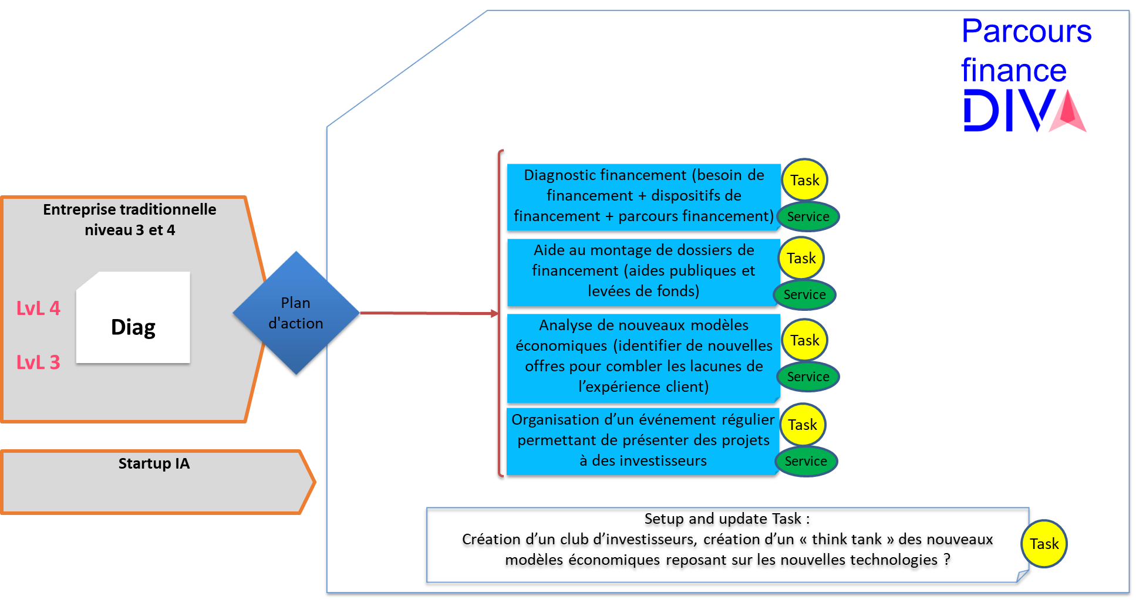
WP6: ACCESS TO FINANCE (Atlanpole)
Duration |  | Mx - Mx |  | Lead beneficiary
Objectives (expected outcome)
Permettre le financement du projet de digitalisation via l'IA, selon le(s) mode(s) de financement le(s) plus pertinent(s) - prototypage et mise en production.
Aider à intégrer le projet de digitalisation à la stratégie de l'entreprise bénéficiaire
Description of the activities (what, how, where) and division of work
No | Task Name | Description |  |  | Participant |  | In-kind contributions and subcontracting  (yes/no and which)
 |  |  |  |  | Name | Role
6.0 | Initialisation & setup of the activities | Lister tous les financements existants pour l'IA et répertorier les investisseurs pertinents (BPI, banques, investisseurs). Mettre en place des partenariats avec les banques, investisseurs ... |  |  | Atlanpole |  | Contribution en nature
6.1 | Veille sur le financement | Veille permanente pour tenir les catalogues de financement et financeurs.  Animation en proposant des workshops "actus des financements de l'IA, avec REX, témoignages) |  |  | Atlanpole, technopoles ligériennes |  | Contribution en nature
6.2 | Assessment of financing needs | Diagnostic financier du projet IA au sein de l'entreprise. Définition d'un plan de financement (plan d'actions). Ce plan de financement dépendra de la typologie de l'entreprise (PME ou startup) et des actions du parcours technique de DIVA. |  |  | Atlanpole, technopoles ligériennes |  | Contribution en nature  Objectif/an : 30 (à affiner avec les objectifs de diagnostic)
6.3 | Strategic support – New business models | Accompagnement à la stratégie de diversification de l'entreprise quand elle est portée par un projet innovant transformant s'appuyant sur l'IA, sur 6 mois (12 jours d'accompagnement).  - clarifier la stratégie gagnante afin de réussir cette rupture autour d’objectifs et de chantiers prioritaires,  - mettre en réseau pour mobiliser des compétences clés, trouver les ressources nécessaires, construire des partenariats et gagner en visibilité,  articuler les financements, structurer la R&D et développer le projet d’innovation |  |  | Atlanpole, technopoles ligériennes |  | Contribution en nature  Objectif/an : 10 ?
6.4 | Fund raising support (public and private funds) | Accompagnement à la mise en œuvre opérationnelle du plan de financement sur 6 mois (12 jours d'accompagnement) : aide à la rédaction, conseils et relecture des dossiers permettant d'obtenir les financements visés, mise en contact avec les financeurs, suivi du dossier. |  |  | Atlanpole, technopoles ligériennes |  | Objectif/an : 10 ?
6.5 | Aide au montage de projet collaboratif d'innovation. | Aide au montage de consortium, labellisation pôles et financement.  Accompagnement au montage de consortium, labellisation pôles et financement (← financement?): identification d’AAP, identification de partenaires techniques, relecture argumentée de dossier, lettre de soutien au projet (si raccord avec les objectifs de l’AAP et la feuille de route technique du pôle) |  |  | EMC2  I&R |  | Contribution en nature  Objectif/an : 10 ? À voir
6.6 | Investors’ Day / voir si possible de l'intégrer dans le West Data Festival | Evénement annuel permettant de mettre en lien investisseurs et projets DIH  - Site web de l'évènement permettant pour les investisseurs et projets DIH de s'inscrire à l'investor'day et de préparer leur journée (présentation des technos clés, catalogue des projets DIH, catalogue des investisseurs, et plateforme de prise de rdv pour le jour J)  - session individuelle + collective de préparation à la rencontre avec les investisseurs  - 1 jour de rencontres entre les entreprises et les investisseurs (pitchs, rdv formels et informels)  - suivi des levées de fonds réalisées suite à l'Investors'day  Inclus à West Data Festival ? |  |  | Atlanpole, technopoles ligériennes |  | Contribution en nature  Objectif/an : 1 évènement
No | Milestones Name | WP | Lead beneficiary | Means of verification |  | Due date | Description
MS1
MS2
MS3
MS4
No | Deliverable Name | WP | Lead beneficiary | Type | Dissemination | Due date | Description
Dx.1
Dx.2
Dx.3
Dx.4
Dx.5

Services
Description of the service | Market price (€) | Unit of measure | Reduced price offered to SMEs (€)
Workshops actus du financement | 5000 euros | 4 jours / workshop + logistique (lieu, frais de bouche, technique) | Gratuit
Financial Diagnosis | Voir CSB pour le coût horaire moyen Atlanpole 1000 Euros ? | 2 jours / diag | Gratuit
Strategic Support + Exploration of new business models / inbucation = accompagnement sur 6 mois à la stratégie globale et au financement. (= Tech4Growth ???) | 6000 euros? | 12 jours / accompagnement | ???
Fund raising support | 6000 euros? | 12 jours / accompagnement | 4000€
Aide au montage de projet collaboratif au montage de projet collaboratif : identification d’AAP, identification de partenaires techniques, relecture argumentées de dossier, lettre de soutien au projet (si raccord avec les objectifs de l’AAP et la feuille de route technique du pôle), labellisation |  | Entre 0,5 et 2 jours par projets | Gratuit DIVA ? Valider avec les pôles
Investors' Day (prendre exemple Start West) | 30 000€ si inclus dans un évènement existant (westDataFestival par exemple)  40000€ si évènement dédié | temps humain organisation, sélection et préparation des candidats, prospection des investisseurs, organisation des pitchs et rdvB2B... (20000€)  + Contribution financière à l'évènement accueillant (10000€)  Ou bien gestion de l'ensemble de la logistique (20000€) | 150€

Source of the financing | Target amount (€)
Levées de fonds (amorçage, séries A, B)
Prêts bancaires
Aides publiques (Région, France, EU)  Avances remboursables  Prêts à taux zéro  Subventions  Expérimentations financées sous forme de cascade funding de projet EU | A définir ultérieurement. C’est en fonction des AAP disponibles d’ailleurs n’est-ce pas ?  Attention transformation numérique est différents de la R&D. Pas les mêmes enjeux (TRL), règles EU sur la concurrence déloyale, pas les mêmes financements non plus
IA booster (DGE)

WP7 : Skills and Traning
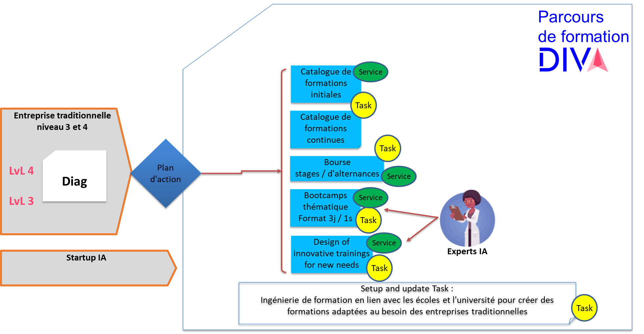
WP7: SKILLS AND TRAINING (Atlanstic 2020 – IMTA)
Duration |  | Mx - Mx |  | Lead beneficiary
Objectives (expected outcome)
Description of the activities (what, how, where) and division of work
No | Task Name | Description |  |  | Participant |  | In-kind contributions and subcontracting  (yes/no and which)
 |  |  |  |  | Name | Role
x.0 | Initialisation & setup of the activities
x.1 | Catalog of trainings
x.2 | Sholarships for work-study
x.3 | Thematic bootcamps
x.4 | Design of innovative trainings for new needs
x.5
No | Milestones Name | WP | Lead beneficiary | Means of verification |  | Due date | Description
MS1
MS2
MS3
MS4
No | Deliverable Name | WP | Lead beneficiary | Type | Dissemination | Due date | Description
Dx.1
Dx.2
Dx.3
Dx.4
Dx.5

Services
Description of the service | Market price (€) | Unit of measure | Reduced price offered to SMEs (€)
Catalog of trainings
Sholarships for work-study
Thematic bootcamps
Design of innovative trainings for new needs

Organiser | Training
 | Type | Subject | Duration (days) | Expected number of attendees

e.g., per hour, per person, per experiment
e.g., per hour, per person, per experiment
e.g., per hour, per person, per experiment
e.g., per hour, per person, per experiment
e.g., per hour, per person, per experiment
workshop, conference, event, ...

